ASSIGNMENT 3 BANKING SYSTEM

J518 Sivasuriya M

TASK 1:

1. Create the database named "HMBank"

CREATE DATABASE HMBANK;

2. Define the schema for the Customers, Accounts, and Transactions tables based on the

provided schema.

CREATE TABLE Customers ( customer_id INT PRIMARY KEY, -- Unique ID for each customer first_name VARCHAR(50) NOT NULL, last_name VARCHAR(50) NOT NULL, DOB DATE NOT NULL, email VARCHAR(100) UNIQUE,phone_number VARCHAR(15) UNIQUE, address TEXT);

4. Create an ERD (Entity Relationship Diagram) for the database. 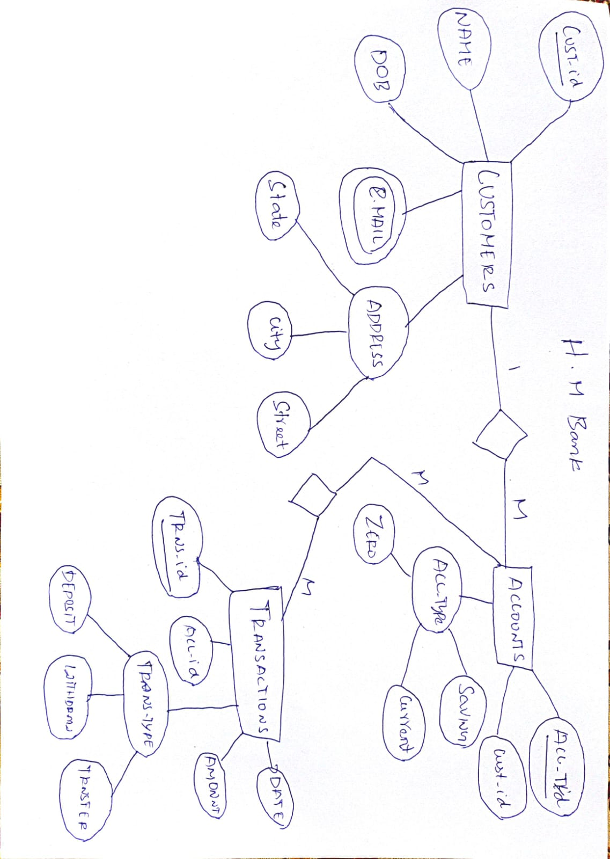

5. Create appropriate Primary Key and Foreign Key constraints for referential integrity.

CREATE TABLE Accounts ( account_id INT PRIMARY KEY, customer_id INT,account_type ENUM('savings', 'current', 'zero_balance') NOT NULL,balance DECIMAL(12,2) DEFAULT 0.00,FOREIGN KEY (customer_id) REFERENCES Customers(customer_id) ON DELETE CASCADE);

6. Write SQL scripts to create the mentioned tables with appropriate data types, constraints,

and relationships.

• Customers

• Accounts

• Transactions

CREATE TABLE Transactions (transaction_id INT PRIMARY KEY AUTO_INCREMENT,account_id INT, transaction_type ENUM('deposit', 'withdrawal', 'transfer') NOT NULL, amount DECIMAL(12,2) NOT NULL CHECK (amount > 0), transaction_date TIMESTAMP DEFAULT CURRENT_TIMESTAMP, FOREIGN KEY (account_id) REFERENCES Accounts(account_id) ON DELETE CASCADE

);

Tasks 2: Select, Where, Between, AND, LIKE:

1. Insert at least 10 sample records into each of the following tables.

• Customers

• Accounts

• Transactions

INSERT INTO Customers (first_name, last_name, DOB, email, phone_number, address) VALUES

('John', 'Doe', '1985-07-15', 'john.doe@email.com', '9876543210', '123 Main St, NY'),

('Alice', 'Smith', '1990-02-20', 'alice.smith@email.com', '9123456789', '456 Elm St, LA'),

('Bob', 'Johnson', '1982-05-10', 'bob.johnson@email.com', '9988776655', '789 Pine St, TX'),

('Emma', 'Brown', '1995-09-25', 'emma.brown@email.com', '9112233445', '321 Oak St, CA'),

('David', 'Miller', '1988-12-30', 'david.miller@email.com', '9001122334', '654 Cedar St, FL'),

('Sophia', 'Wilson', '1993-06-18', 'sophia.wilson@email.com', '9556677889', '987 Maple St, IL'),

('Liam', 'Moore', '1979-11-07', 'liam.moore@email.com', '9445566778', '741 Birch St, NV'),

('Olivia', 'Taylor', '1986-04-03', 'olivia.taylor@email.com', '9334455667', '852 Fir St, WA'),

('James', 'Anderson', '1991-08-22', 'james.anderson@email.com', '9223344556', '963 Willow St, OR'),

('Emily', 'Thomas', '1983-01-11', 'emily.thomas@email.com', '9112233445', '159 Redwood St, MI');

INSERT INTO Accounts (customer_id, account_type, balance) VALUES

(1, 'savings', 5000.00),

(2, 'current', 10000.50),

(3, 'savings', 7500.75),

(4, 'savings', 12000.20),

(5, 'current', 8000.00),

(6, 'savings', 15000.90),

(7, 'zero_balance', 0.00),

(8, 'savings', 20000.00),

(9, 'current', 17500.50),

(10, 'savings', 3000.25);

INSERT INTO Transactions (account_id, transaction_type, amount) VALUES

(1, 'deposit', 1000.00),

(2, 'withdrawal', 500.00),

(3, 'deposit', 2000.50),

(4, 'withdrawal', 800.75),

(5, 'deposit', 3000.00),

(6, 'transfer', 1500.25),

(7, 'deposit', 5000.00),

(8, 'withdrawal', 700.00),

(9, 'transfer', 1200.90),

(10, 'deposit', 2500.50);

2. Write SQL queries for the following tasks:

1. Write a SQL query to retrieve the name, account type and email of all customers.

select c.first_name,c.last_name,a.account_type,c.email from customers c join accounts a on c.customer_id=a.customer_id;

2. Write a SQL query to list all transaction corresponding customer.

select * from transactions where accout_id=101;

3. Write a SQL query to increase the balance of a specific account by a certain amount.

update accounts set balance=balance+500 where account_type='savings';

4. Write a SQL query to Combine first and last names of customers as a full_name

select concat(first_name,last_name) as full_name from customers;

5.Write a SQL query to remove accounts with a balance of zero where the account type is savings.

delete from accounts where account_type='savings' and balance=0;

6. Write a SQL query to Find customers living in a specific city

select * from customers where address like '%NY';

7. Write a SQL query to Get the account balance for a specific account.

select sum(balance) from accounts where account_type='savings';

8. Write a SQL query to List all current accounts with a balance greater than $1,000.

select * from acconuts where account_type='current' and balance>1000;

9. Write a SQL query to Retrieve all transactions for a specific account.

select * from transactions where account_id=101;

10. Write a SQL query to Calculate the interest accrued on savings accounts based on a given interest rate.

select account_id,balance,balance * 0.05 as Interest_accrued from acconuts where account_type='savings';

11. Write a SQL query to Identify accounts where the balance is less than a specified overdraft limit.

select * from accounts where balance<1000;

12. Write a SQL query to Find customers not living in a specific city.

select * from customers where address not like '%NY';

Tasks 3: Aggregate functions, Having, Order By, GroupBy and Joins:

1. Write a SQL query to Find the average account balance for all customers.

select avg(balance) as average_balance from accounts;

2. Write a SQL query to Retrieve the top 10 highest account balances.

select balance from accounts order by balance desc limit 10;

3. Write a SQL query to Calculate Total Deposits for All Customers in specific date.

select sum(amount) from transactions where day(transaction_date)=18;

4. Write a SQL query to Find the Oldest and Newest Customers.

select c.customer_id,concat(first_name,last_name) as oldest_customer from customers c join accounts a on c.customer_id=a.customer_id join transactions t on a.account_id=t.account_id order by transaction_date desc limit 1;

SELECT c.customer_id,concat(first_name,last_name) as newest_customer from customers c join accounts a on c.customer_id=a.customer_id join transactions t on a.account_id=t.account_id order by transaction_date limit 1;

5. Write a SQL query to Retrieve transaction details along with the account type.

select a.account_type,t.transaction_id,t.account_id,t.transaction_type,t.amount,t.transaction_date from Accounts a join Transactions t on a.account_id=t.account_id;

6. Write a SQL query to Get a list of customers along with their account details.

select c.customer_id,c.first_name,c.last_name,c.DOB,c.email,c.phone_number,c.address,a.account_id,a.account_type,a.balance from customers c join accounts a on c.customer_id=a.customer_id;

7. Write a SQL query to Retrieve transaction details along with customer information for a specific account.

select t.*,c.customer_id,c.first_name,c.last_name from customers c join accounts a on c.customer_id=a.customer_id join transactions t on t.account_id=a.account_id where t.account_id=101;

8. Write a SQL query to Identify customers who have more than one account.

select c.*,count(a.account_id) from customers c join accounts a on c.customer_id=a.customer_id group by c.customer_id having count(a.account_id)>1;

9. Write a SQL query to Calculate the difference in transaction amounts between deposits and withdrawals.

select sum(case when transaction_type='deposits' then amount end) - sum(case when transactions_type='withdrawal' then amount end) as difference from transactions;

10. Write a SQL query to Calculate the average daily balance for each account over a specified

period.

select avg(amount) from transactions where transaction_date between '2025-03-18' and '2025-04-15' group by account_id;

11. Calculate the total balance for each account type.

SELECT SUM(BALANCE) FROM ACCOUNTS GROUP BY account_type;

12. Identify accounts with the highest number of transactions order by descending order.

select count(account_id) from transactions group by account_id order by account_id desc;

13. List customers with high aggregate account balances, along with their account types.

select max(balance) as highest_balance, account_type from accounts;

14. Identify and list duplicate transactions based on transaction amount, date, and account.

select transaction_id,account_id,transaction_type,amount,transaction_date,account_type,count(*) from transactions group by amount,transaction_date,account_type having count(*)>1;

Tasks 4: Subquery and its type:

1. Retrieve the customer(s) with the highest account balance.

select c.*,a.balance from customers c join accounts a on a.customer_id=c.customer_id where balance =(select max(balance) from accounts);

2. Calculate the average account balance for customers who have more than one account.

select customer_id,avg(balance) from accounts group by customer_id having count(account_id)>1;

3. Retrieve accounts with transactions whose amounts exceed the average transaction amount.

select a.* from accounts a join transactions t on t.account_id=a.account_id where t.amount>(select avg(amount) from transactions);

4. Identify customers who have no recorded transactions.

select customer_id from customers where customer_id not in (select customer_id from accounts where account_id in (select account_id from transactions));

5. Calculate the total balance of accounts with no recorded transactions.

select sum(balance) from accounts where account_id not in(select account_id from transactions);

6. Retrieve transactions for accounts with the lowest balance.

select * from transactions where account_id in(select account_id from accounts where balance in (select min(balance) from accounts));

7. Identify customers who have accounts of multiple types.

select customer_id from accounts group by customer_id having count(distinct account_type) >1;

8. Calculate the percentage of each account type out of the total number of accounts.

select account_type, (count(*)/(select count(*) from accounts))*100.0 as percentage from accounts group by account_type;

9. Retrieve all transactions for a customer with a given customer_id.

select * from transactions where account_id in (select account_id from accounts where customer_id in(select customer_id from customers where customer_id=101));

10. Calculate the total balance for each account type, including a subquery within the SELECT clause.

select distinct account_type ,(select sum(balance) from accounts a where a.account_type=b.account_type ) as total_balance from accounts b;